NATGATEWAY
STEP 1:CRAETE VPC
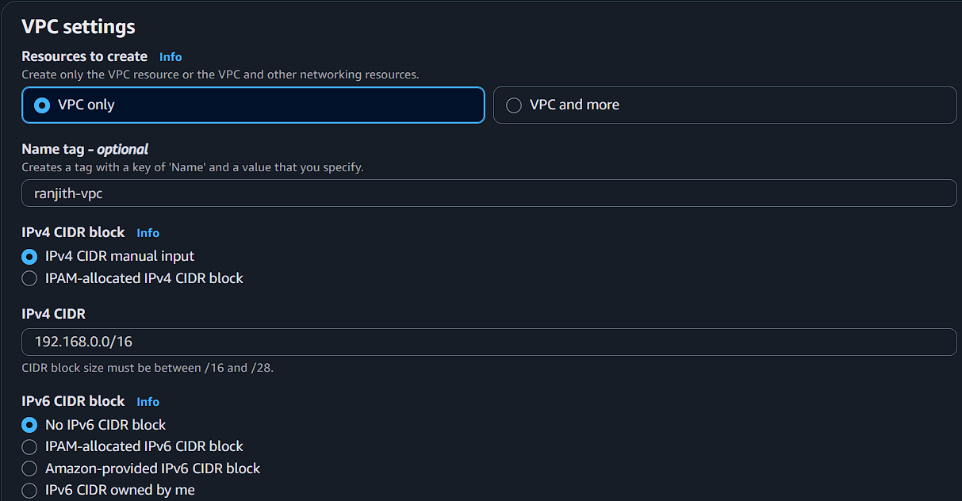

STEP 2:ADD SUBNETS (CLICK SUBNET)
PUBLIC SUBNET
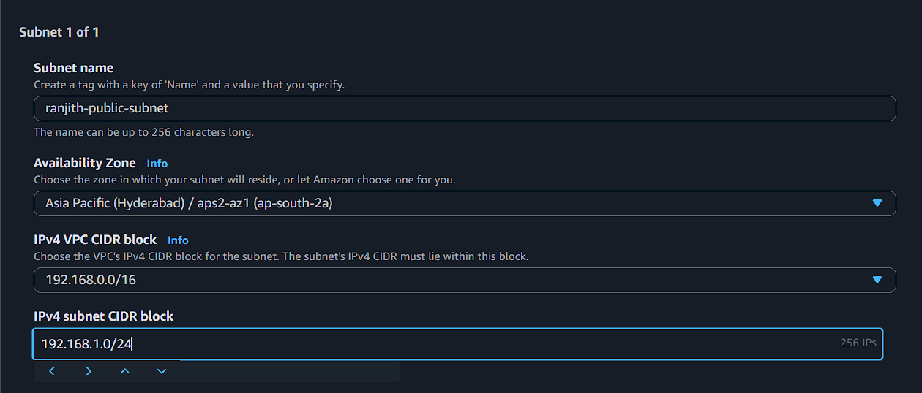
PRIVATE SUBNET
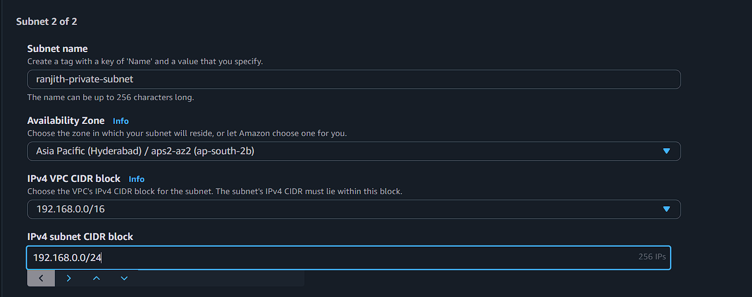
Click create

STEP 3:CREATE INTERNET GATEWAY

Attach the internet gateway in vpc
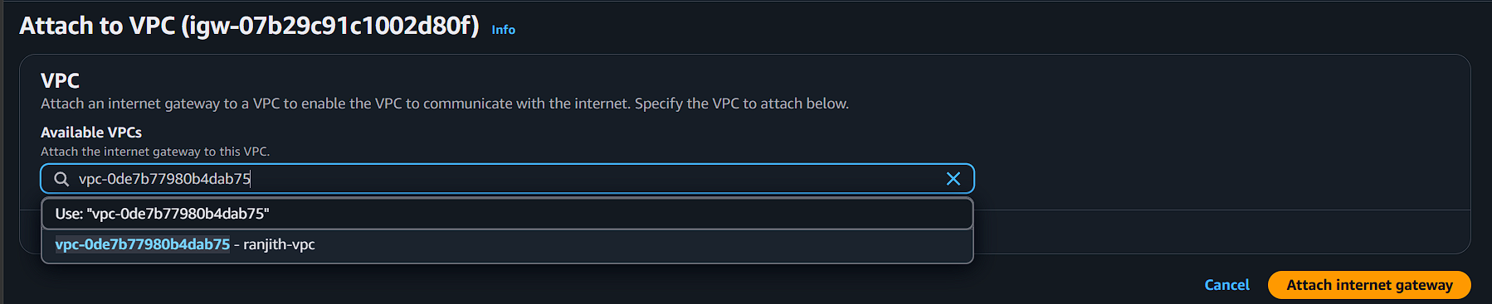

STEP 4 :CREATE PUBLIC ROUTE TABLE
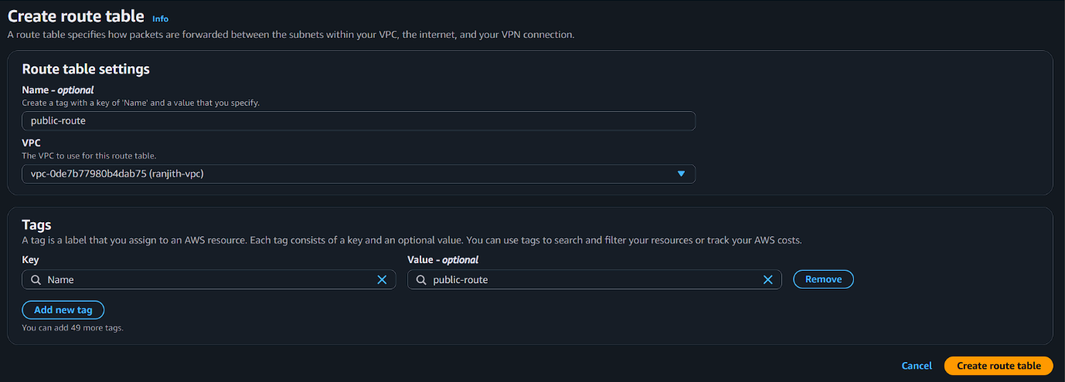

STEP 5 :CREATE PRIVATE ROUTE TABLE
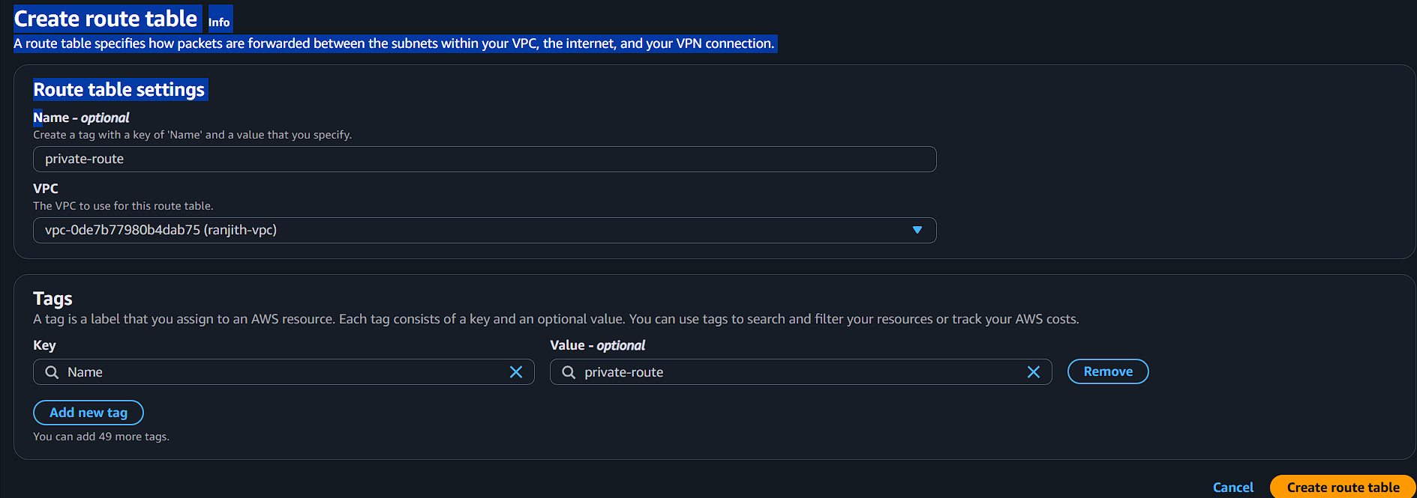

EDIT THE ROUTE TABLE
ACTIONEDIT SUBNET ASSOCIATIONS
ATTACH THE PRIVATE AND PUBLIC SUBNETS IN SEPARATE ROUTE TABLES
PUBLIC
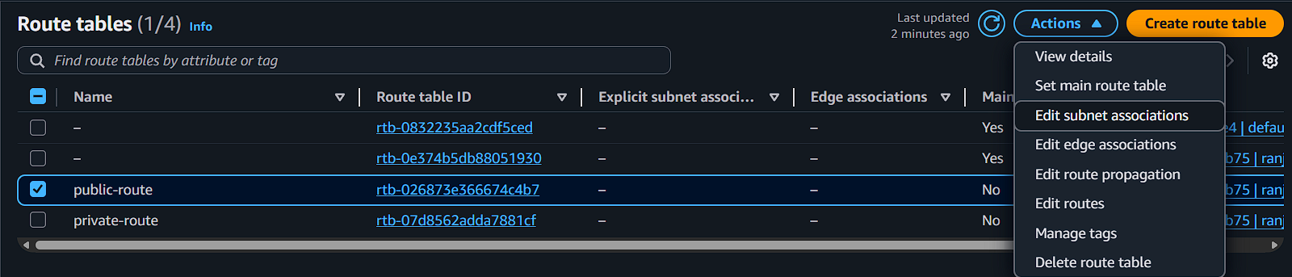
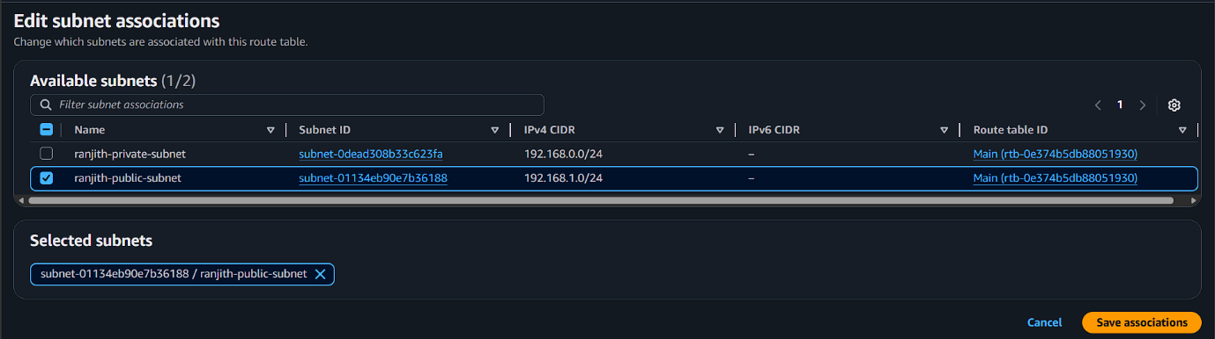
EDIT ROUTE
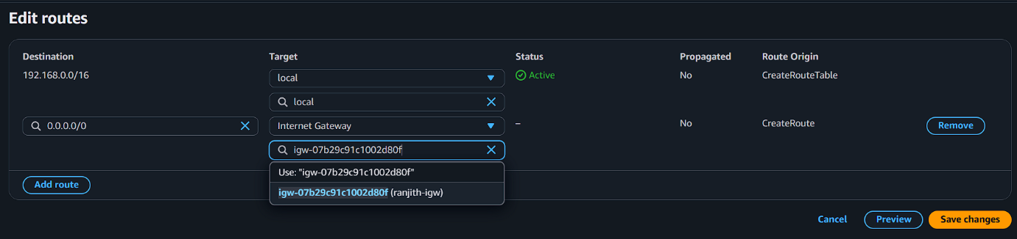

PRIVATE
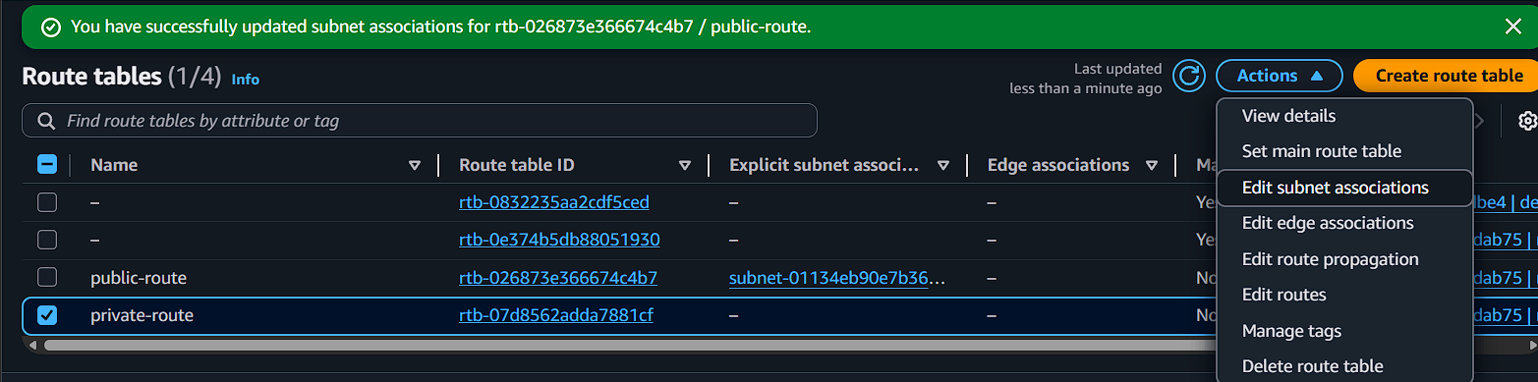
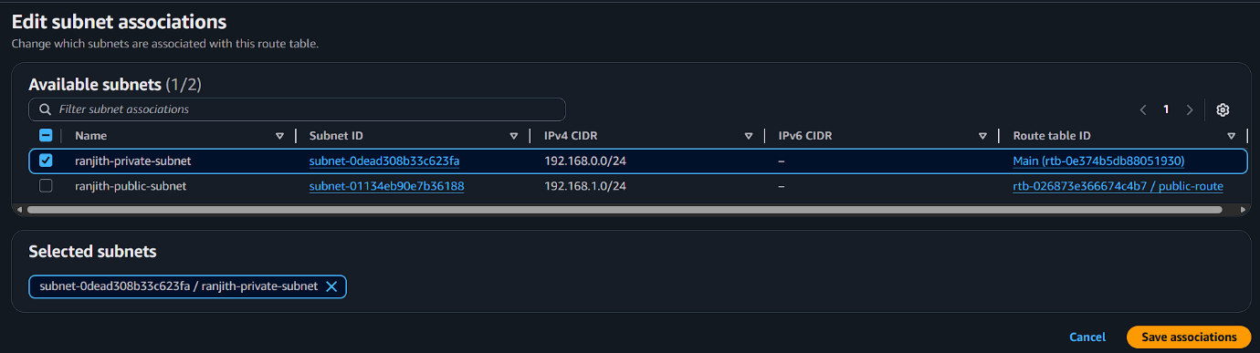

STEP 6:CREATE EC2 INSTANCE 2(PRIVATE AND PUBLIC)
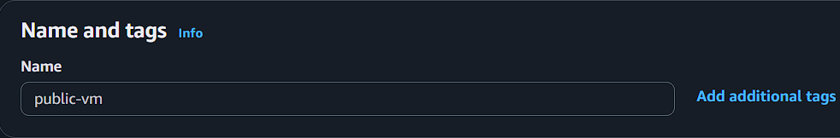
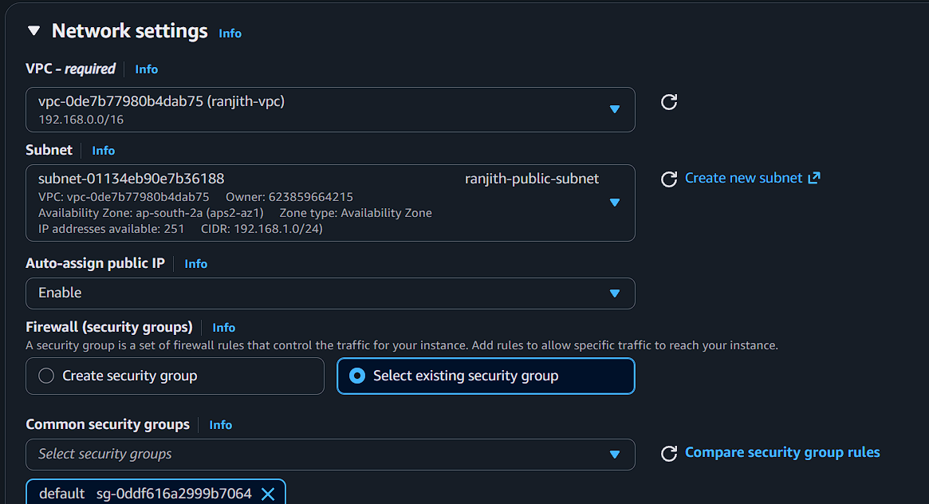
Private vm


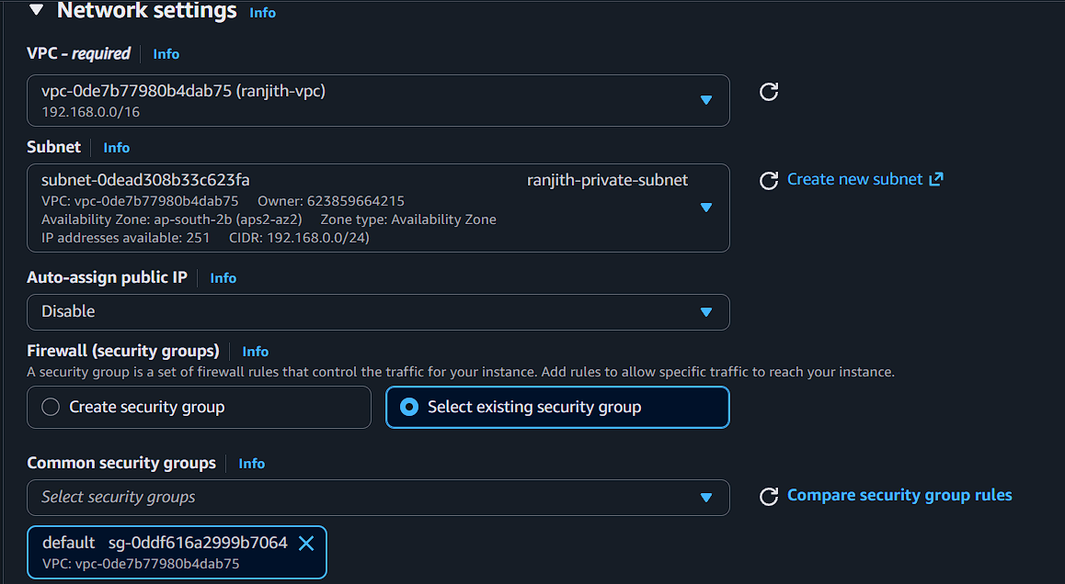

Connect the EC2 INSTANCE IN TERMINAL
PUBLIC
Test using ping for network connection
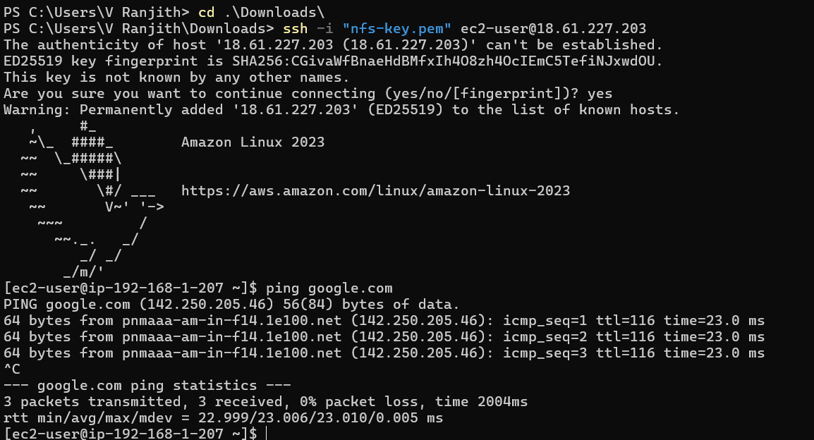
PRIVATE
Test using ping for network connection
Copy the public key contents in windows downloads file and store the key contents in linux public terminal….
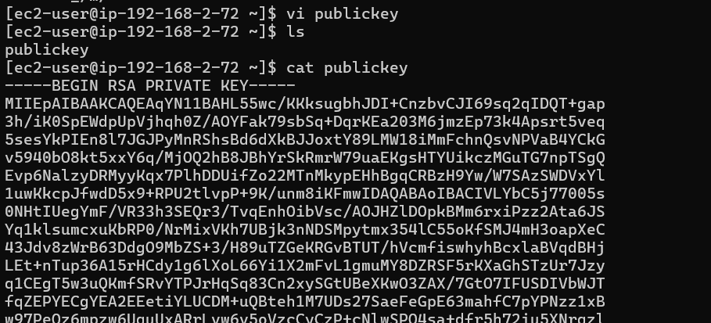
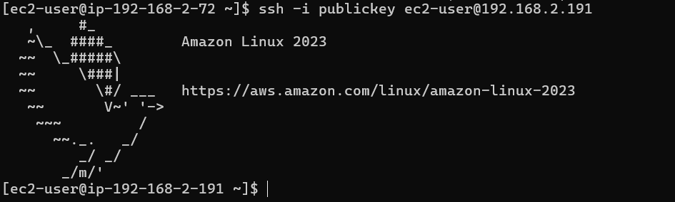

NOT ping because the network connection is off for private-vm

STEP 7:CREATE NAT GATEWAY
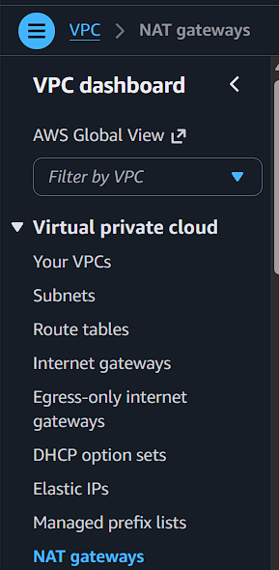
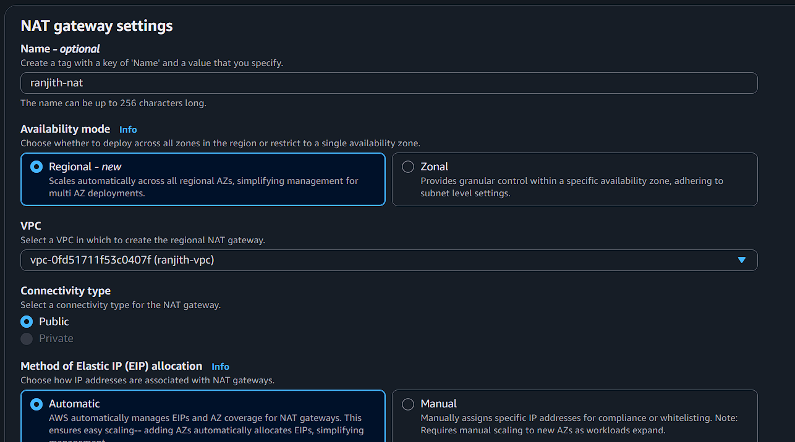

GO TO ROUTE TABLE AND CLICK EDIT ROUTE
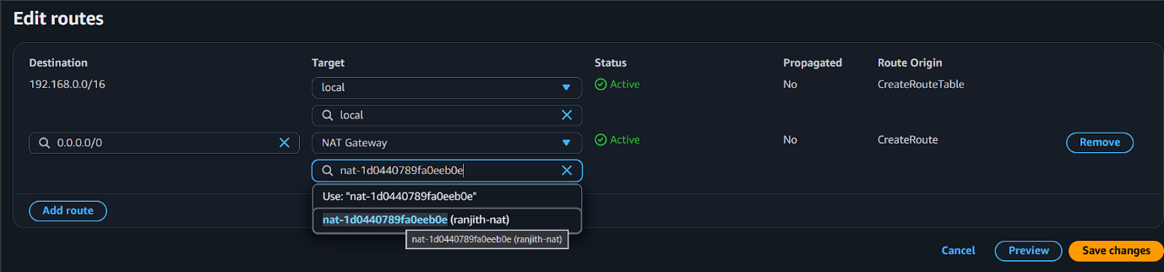

NOW CHECK THE PRIVATE VM

